Introduction

Lesson Introduction

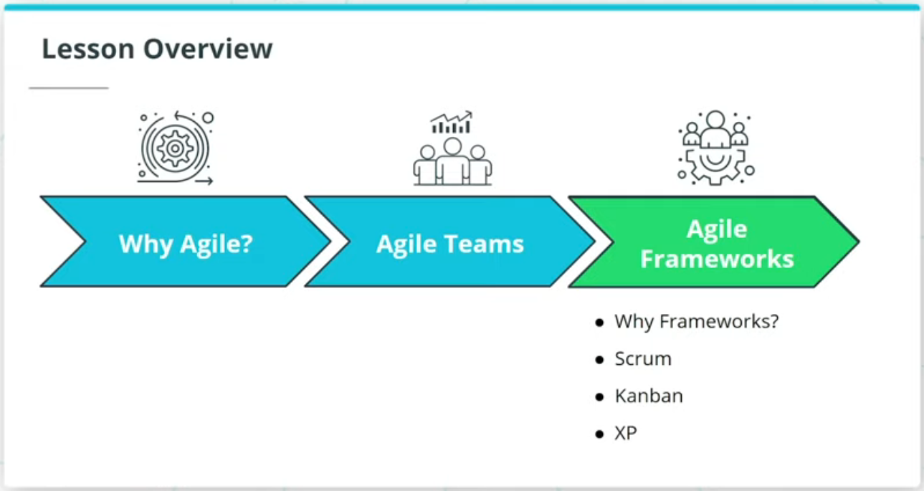

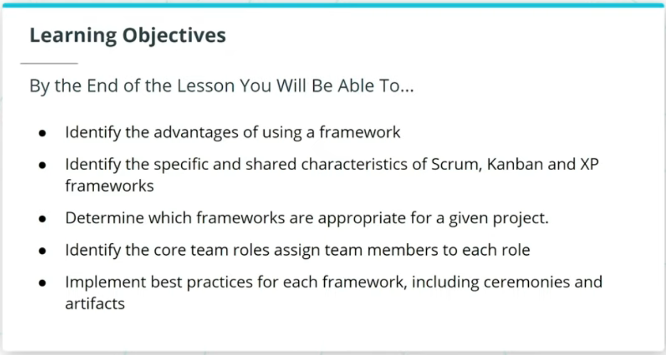

### **What We Will Cover In This Lesson**

Nice to see you again. This lesson will focus on Agile Frameworks, with the topic being covered as follows:

* Introduction to Agile Frameworks in general and what the advantages are of using a framework.
* The Scrum Framework and its unique characteristics as a valuable Framework.
* The more lightweight Kanban Framework and its unique advantage in managing flow and WIP
* The XP Framework and its advantages, with an appreciation for its more stringent best practices.

### **By the End of the Lesson You Will Be Able To...**

* Identify the advantages of using a framework
* Identify the specific and shared characteristics of Scrum, Kanban, and XP frameworks
* Determine which frameworks are appropriate for a given project
* Identify the core team roles assign team members to each role
* Implement best practices for each framework, including ceremonies and artifacts

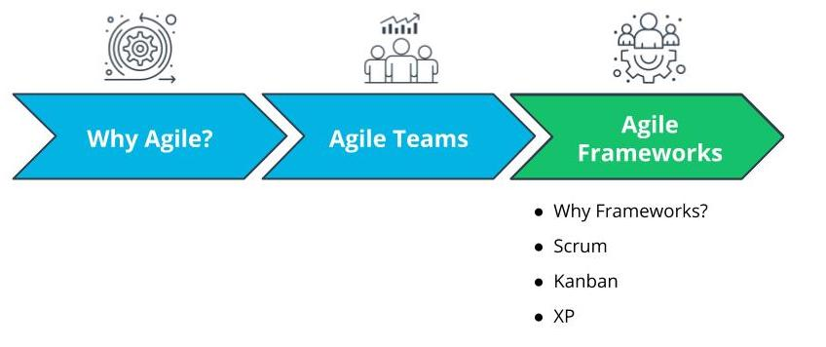

What We Will Cover In This Lesson

# Why Agile Frameworks?

## Why Do Agile Frameworks Matter?

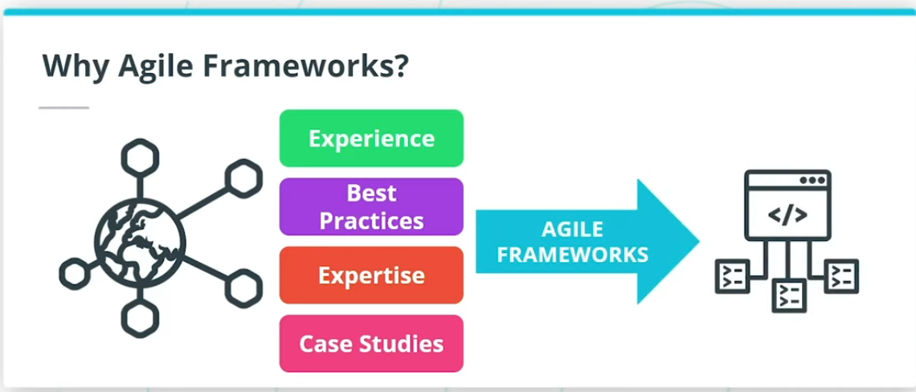

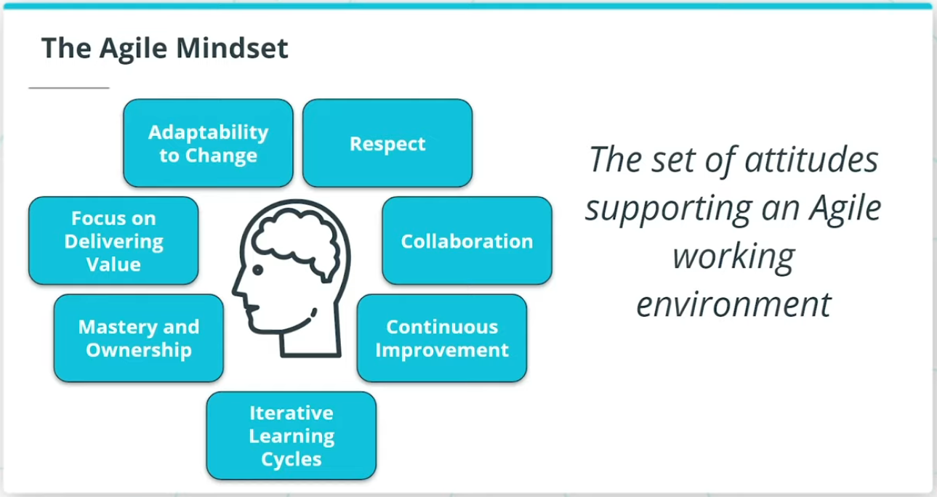

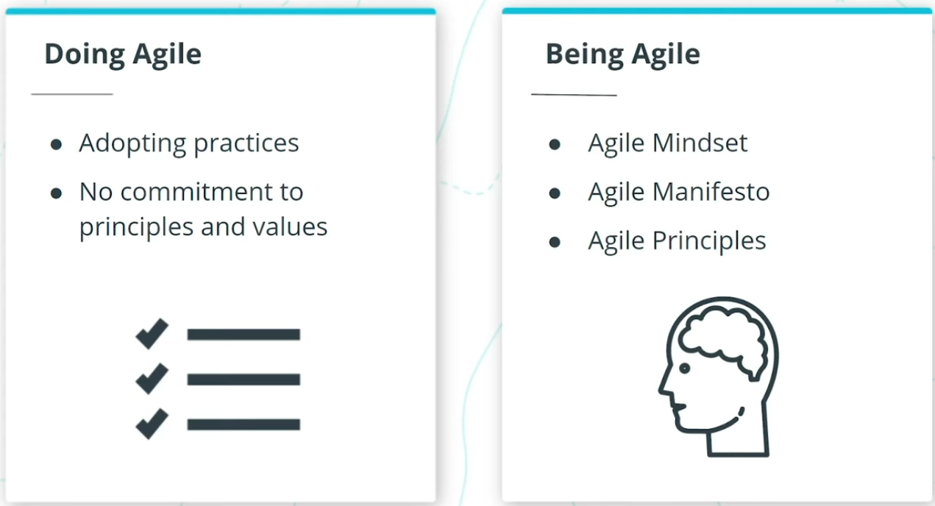

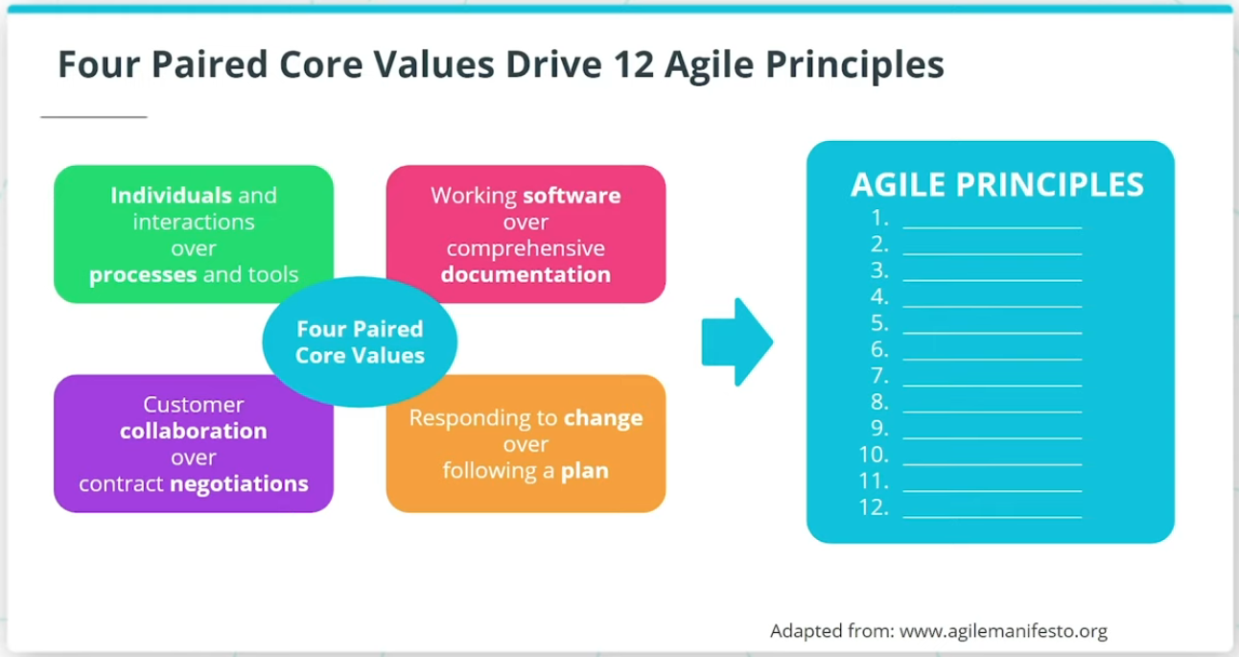

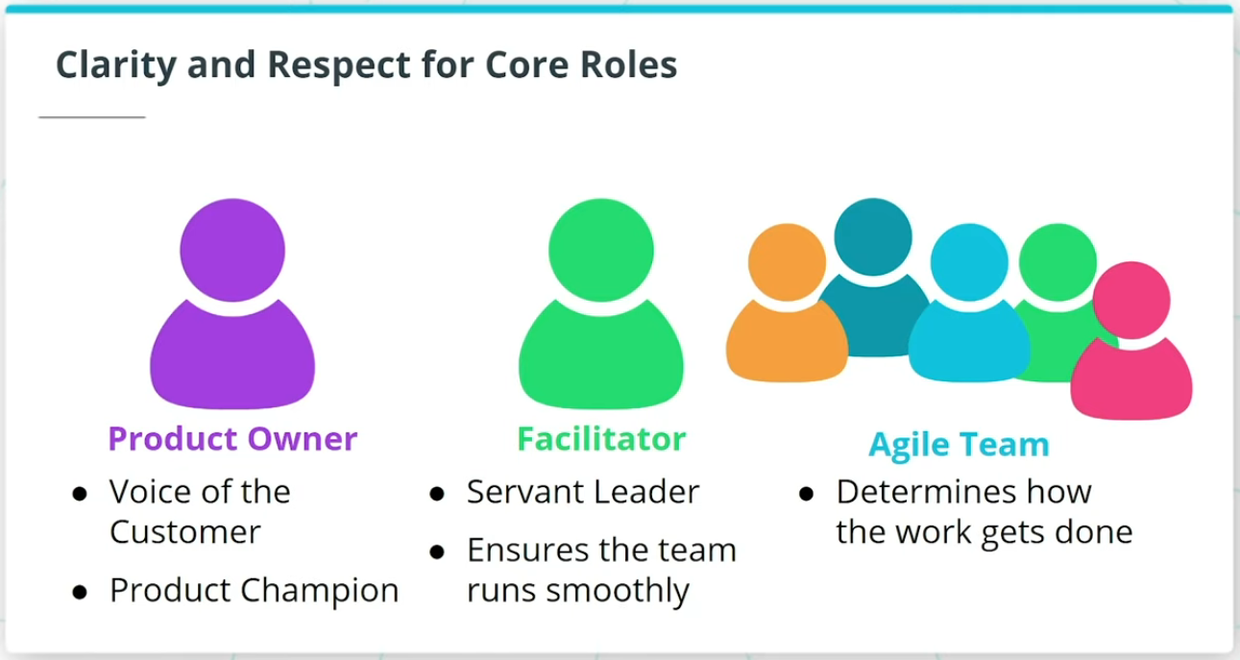

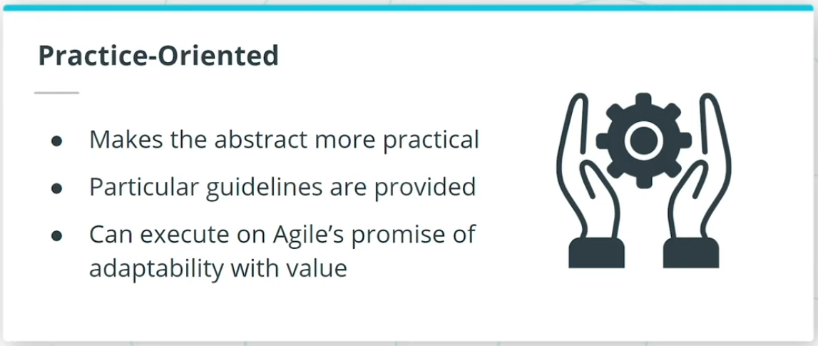

### **Agile Frameworks Are A Vehicle for Practically Utilizing Agile**

Agile's principles related to simplicity, adaptability, and the ability to embrace change attract attention. For Agile to practically be utilized effectively, an Agile Framework, or a combination of frameworks, is usually adopted.

### **Similarities Between Agile Frameworks:**

* Adhere to the Agile Mindset as being fundamental to the success of any Agile journey
* Emphasize that being Agile is critical to successfully doing Agile
* The Agile Manifesto’s 4 paired core values and its associated 12 guiding principles set the foundation for all Agile Frameworks
* Provide guidance on how to bring the Agile Manifesto’s core values and principles to life

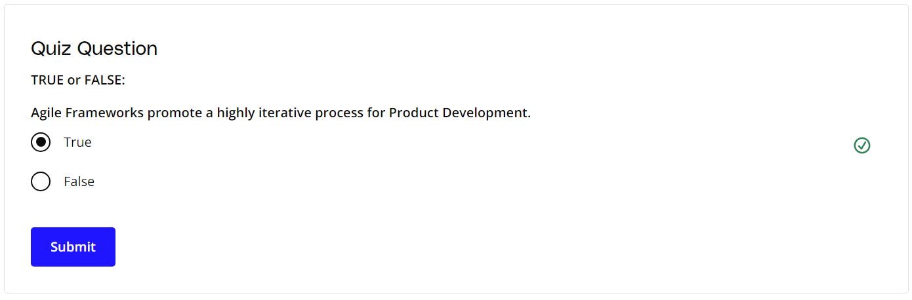

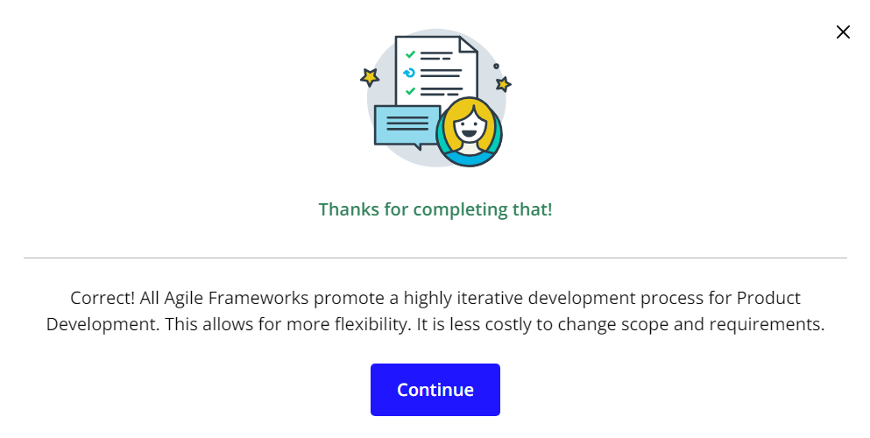

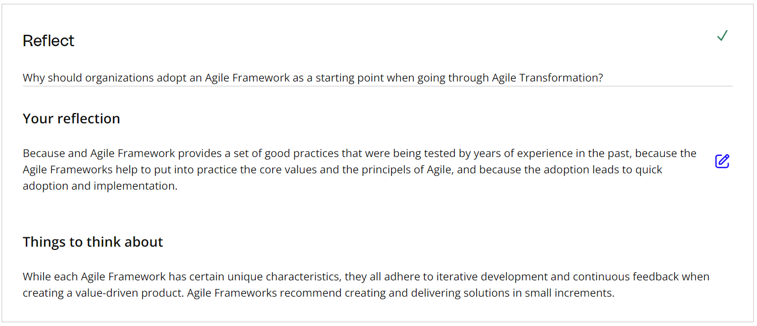

### **Additional Resources**

* [**The Best Framework to Use for a Successful Agile Transformation(opens in a new tab)**](https://www.projectmanagement.com/blog-post/62476/The-Best-Framework-to-Use-for-a-Successful-Agile-Transformation): In this blog post, Al Shalloway walks through the value of Agile Frameworks.

# How Experts Approach Agile Frameworks

## Thinking About Agile Frameworks



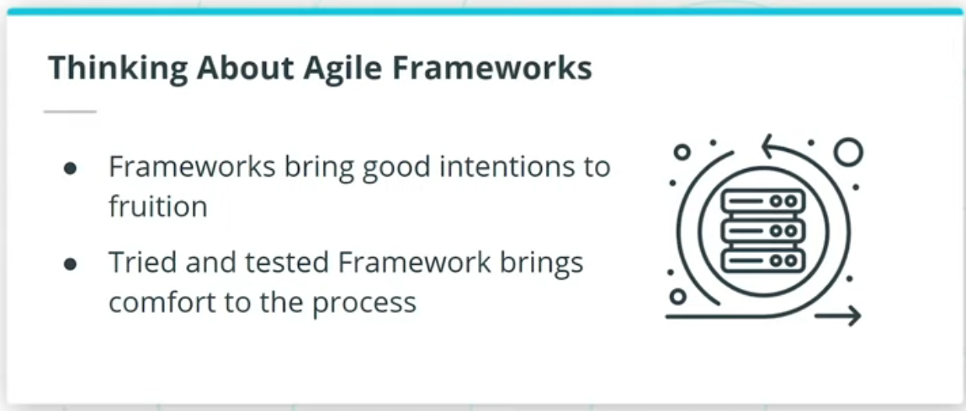

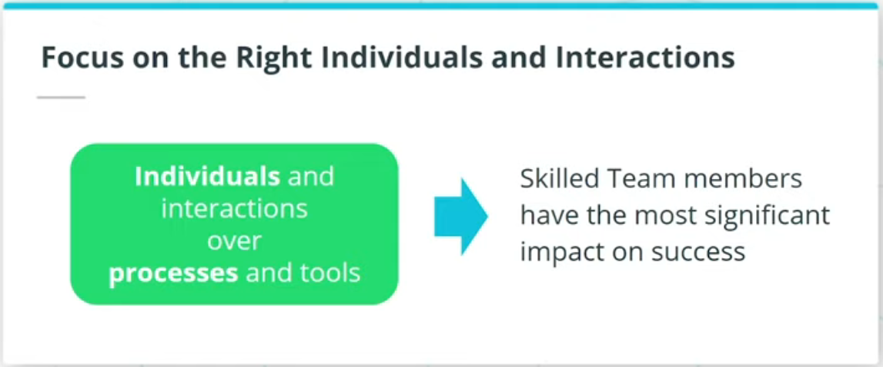

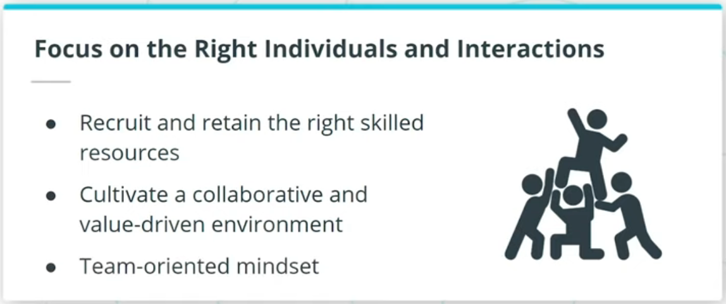

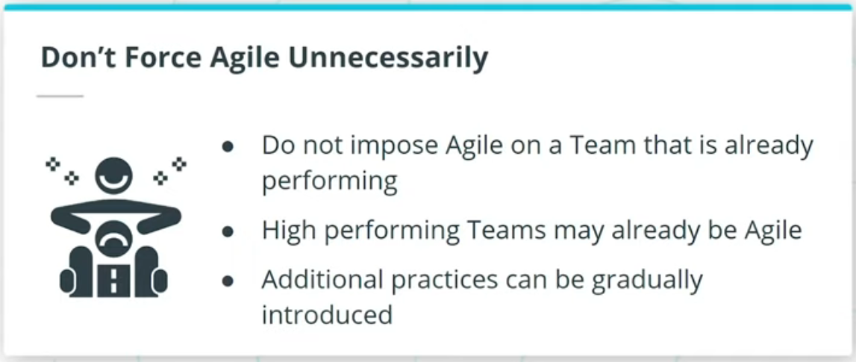

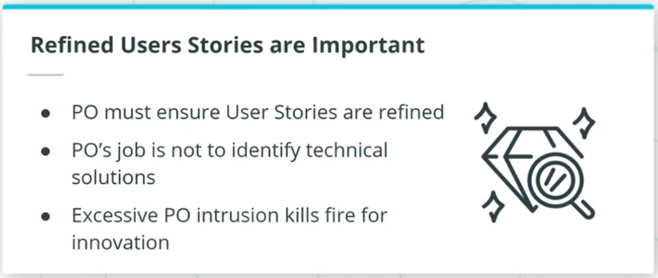

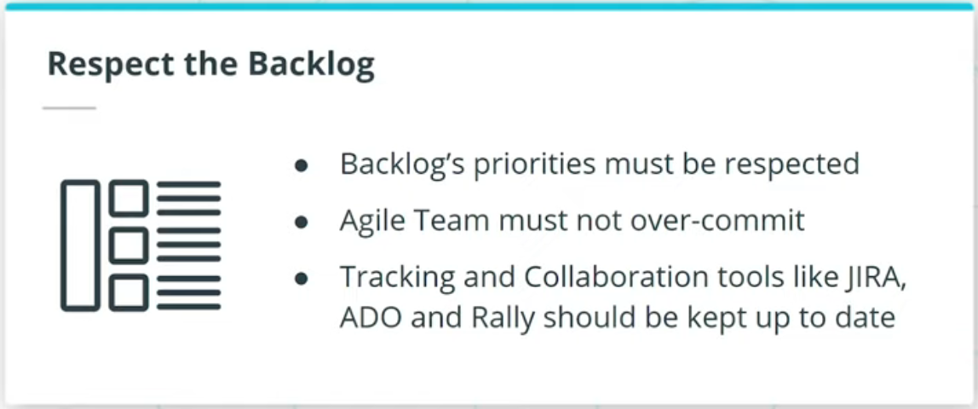

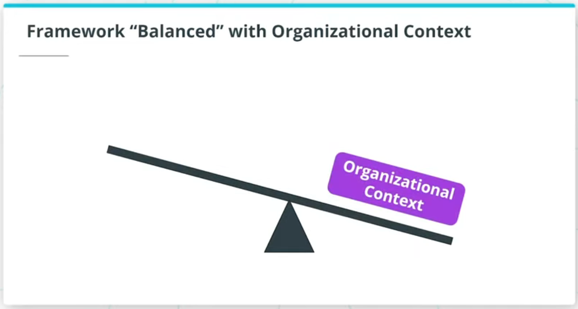

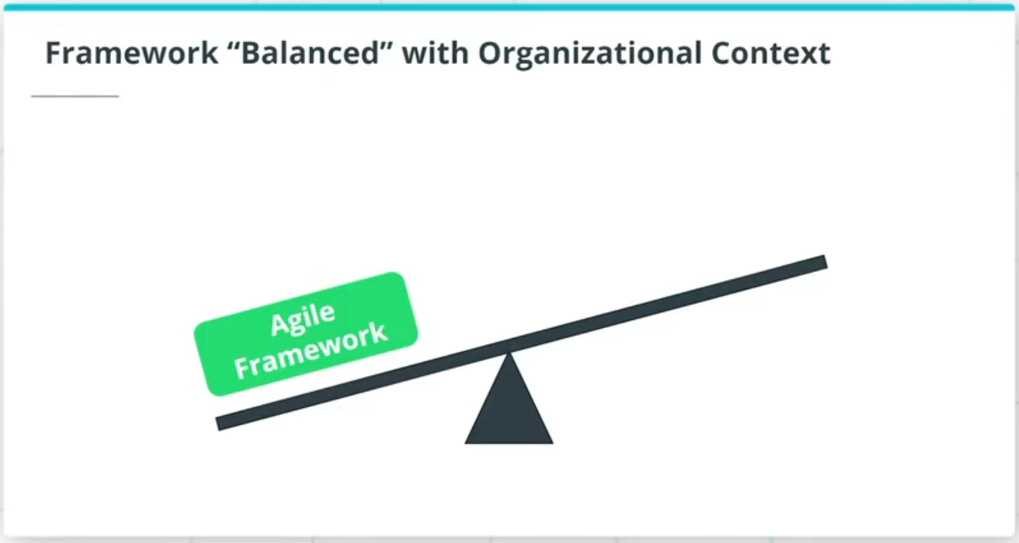

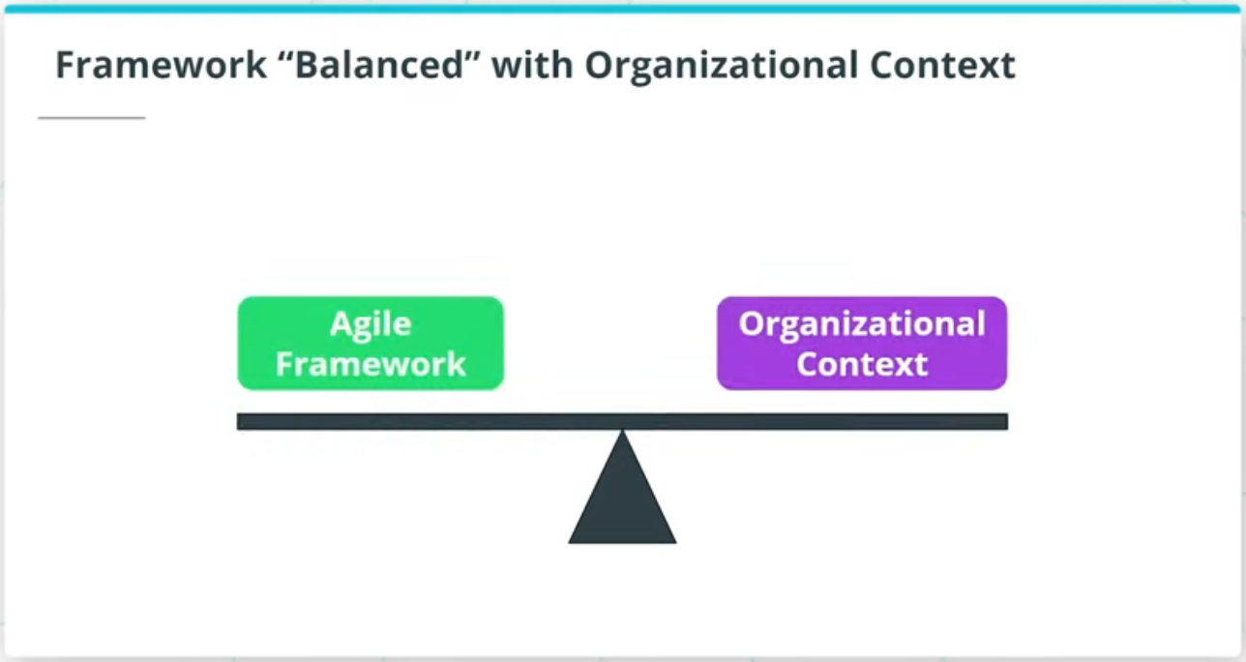

### **Agile Frameworks are Enablers that Bring to Fruition the Value of Agile**

This includes:

* Focusing more on the individuals and interactions; ultimate determining factor for the success of a product are the resources on the Agile product delivery team.
* Do not force Agile unnecessarily; Teams that are already performing well can be gradually introduced to additional Agile practices based on a specific Agile Framework.
* Refined user stories are important; Agilists work with Product Owners to ensure the user stories have been sufficiently refined for the Agile Team to proceed.
* Respect the backlog; Agilists focus on ensuring the Agile Team does not over-commit to what can be accomplished in each iteration, especially during the first few iterations.

### **Implementing a Specific Agile Framework is a Fine Balancing Act**

* Must adapt based on each organization’s unique culture and context.
* Experts have to regularly remind both leaders and the Agile Team to remember that there is no one way to execute Agile practices in an organization.
* Agile principles and practices are by their very nature to be adapted as needed.

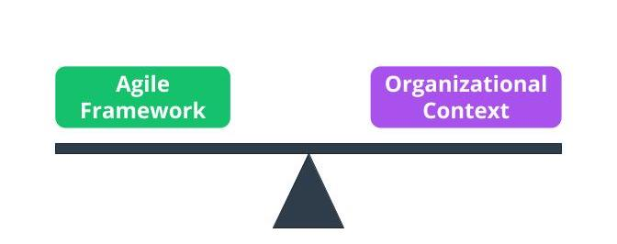

Framework “Balanced” with Organizational Context

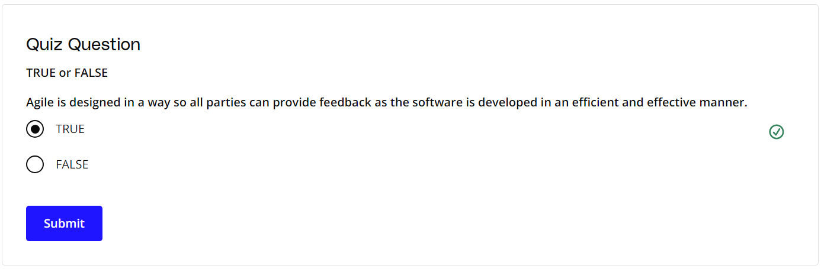

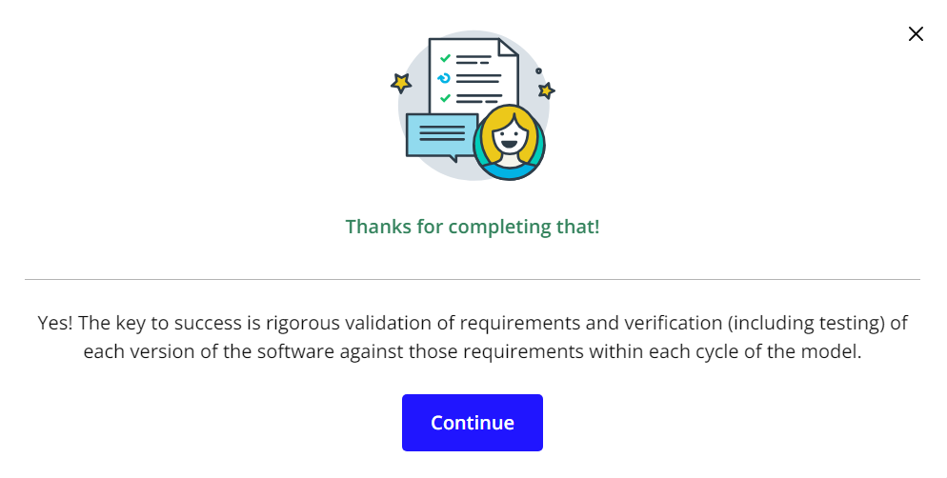

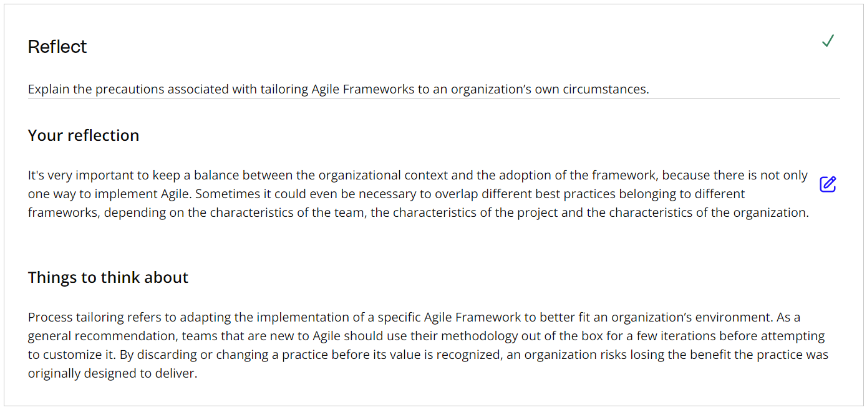

### **Additional Resources**

* [**Advanced Topics in Agile Planning(opens in a new tab)**](https://www.mountaingoatsoftware.com/presentations/advanced-topics-in-agile-planning): In this presentation, Mike Cohn walks through Advanced Agile Planning.

# Agile Frameworks

## What Are Agile Frameworks?

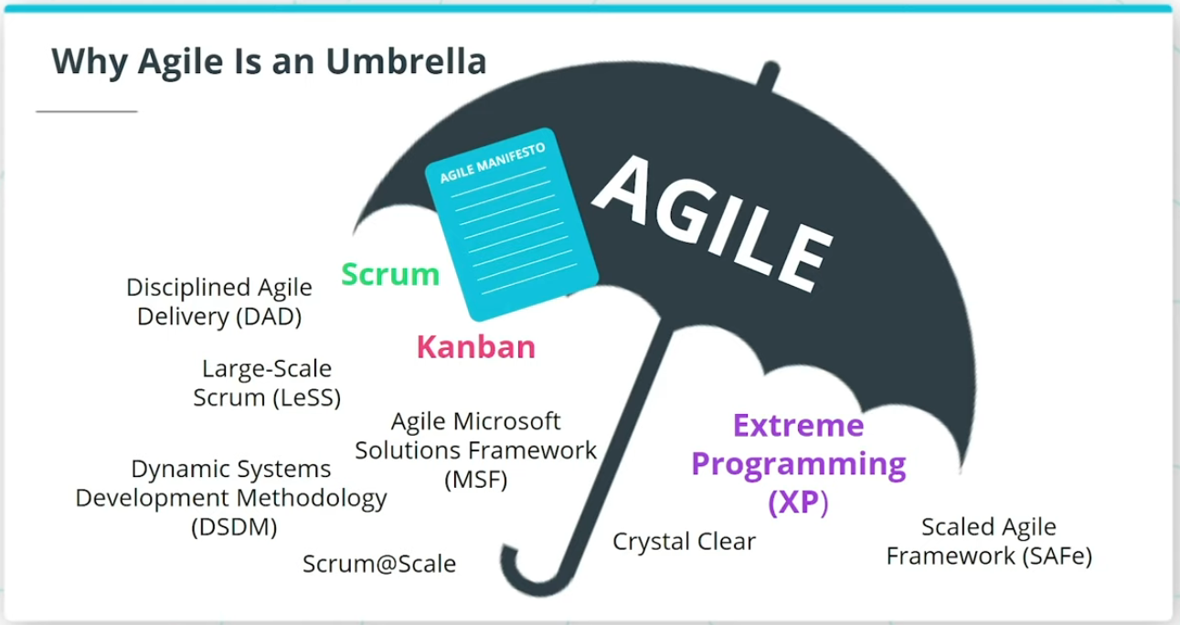

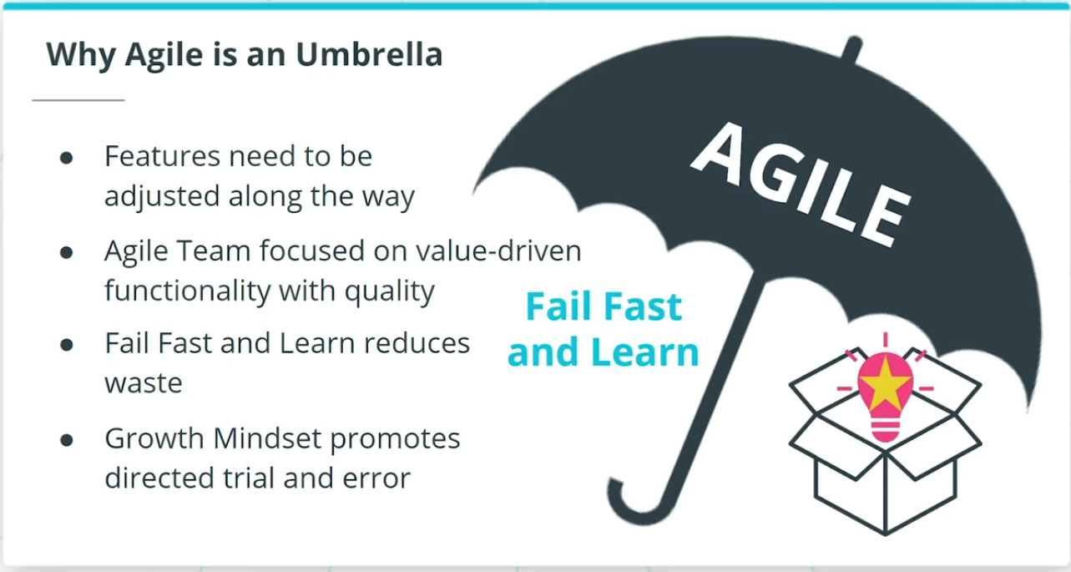

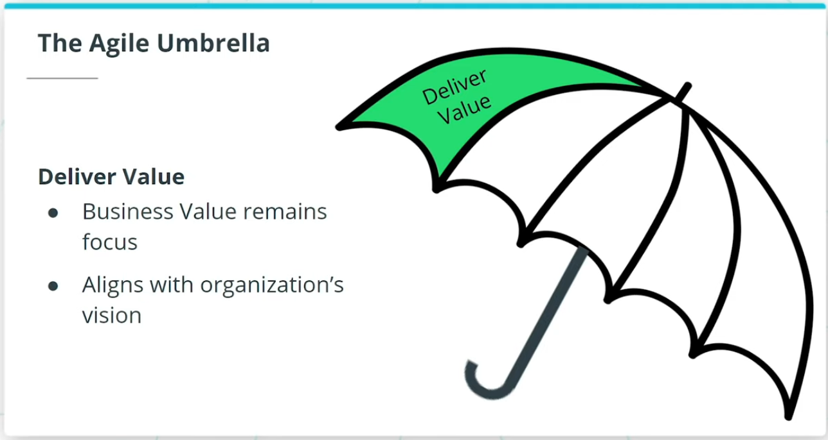

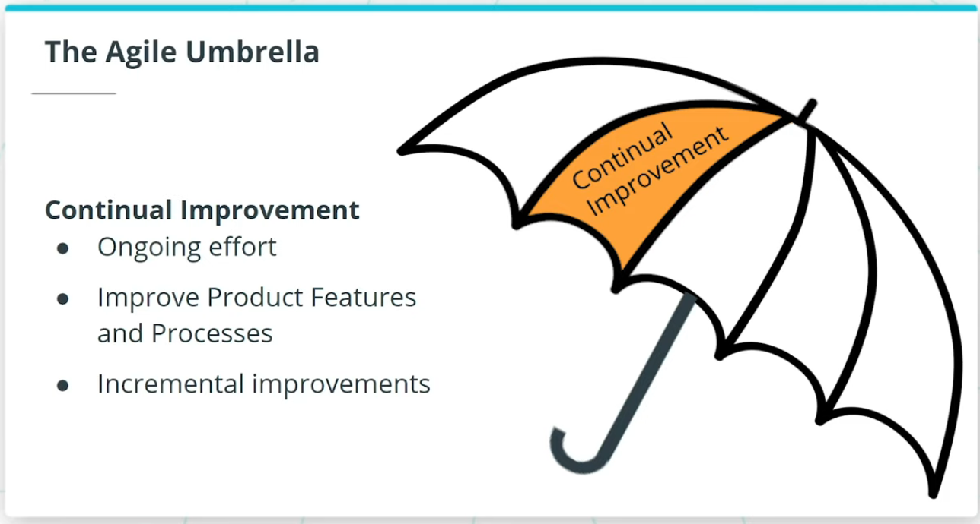

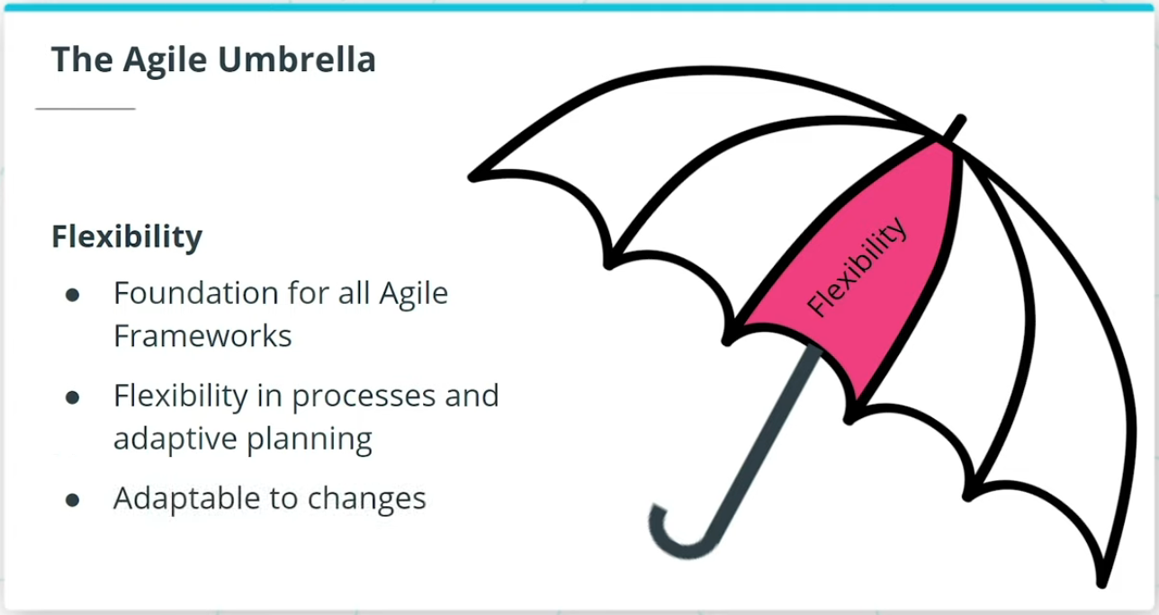

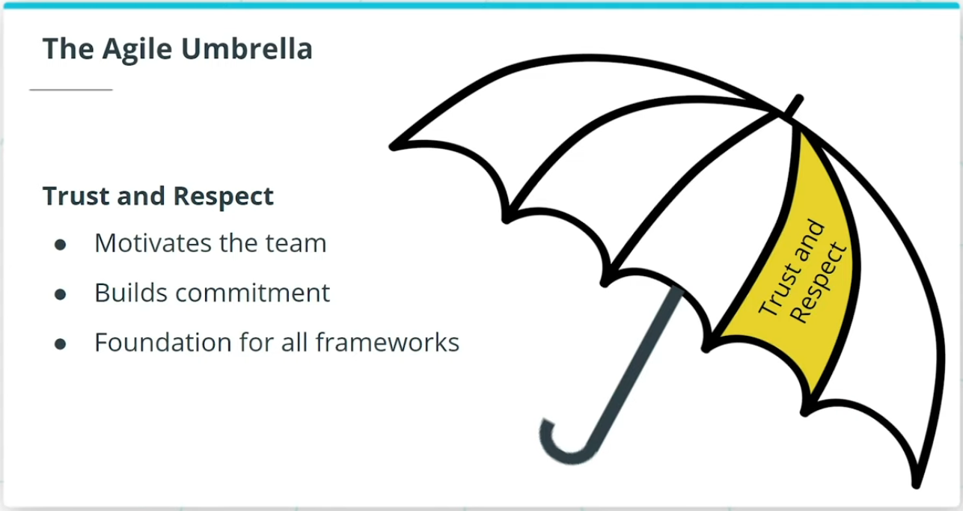

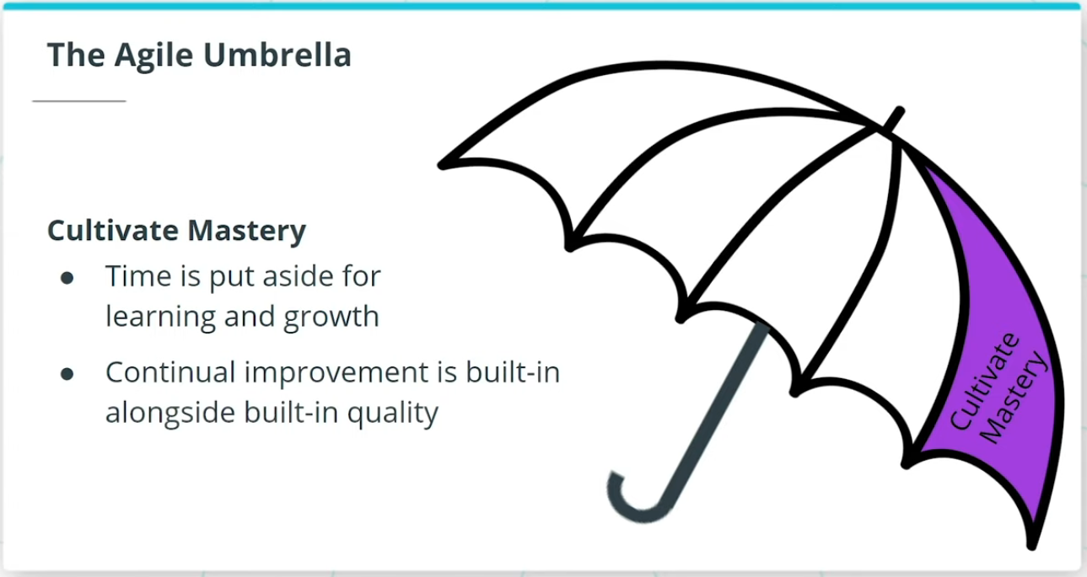

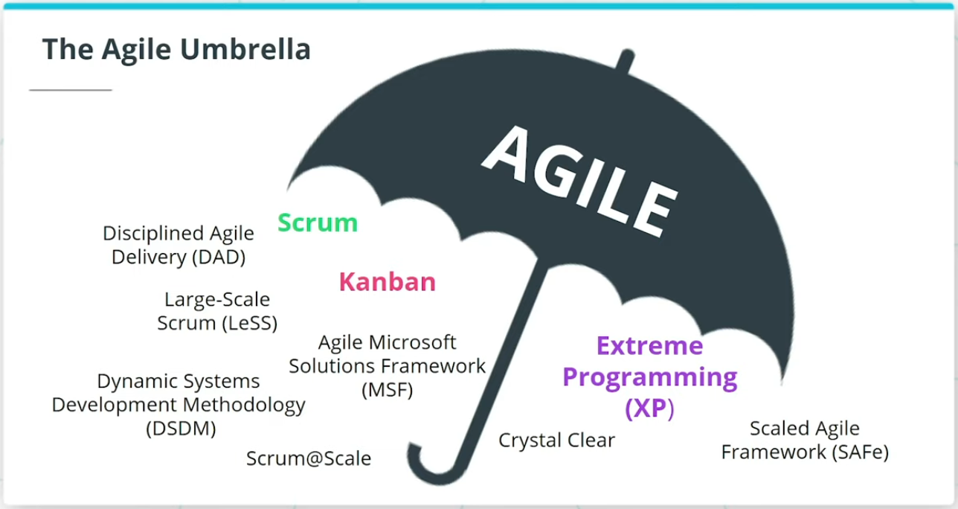

### **Agile is an Umbrella Term for a Variety of Frameworks that Align with The Agile Manifesto**

Every Agile team's goal is to deliver value-driven functionality with built-in quality and to do it quickly. This is where **Fail Fast and Learn** is priceless. Agile teams who wish to deliver both amazing product features that delight customers, as well as do it fast, must learn to quickly change course when it is realized that a product feature is heading down the wrong path.

### **The Agile Umbrella**

The Agile Umbrella has some key characteristics:

* **Deliver Value**: An absolutely key driver behind anything Agile is to deliver value.
* **Continual Improvement**: Agile promotes incremental improvement to minimize resistance from all who are involved.
* **Flexibility**: Flexibility is one of the foundations of any Agile Framework.
* **Trust and Respect**: Agile Frameworks promote trust and respect because such trust and respect motivate Agile teams.
* **Cultivate Mastery**: This built-in structure for Agile team members to hone their skills further motivates the Agile team.

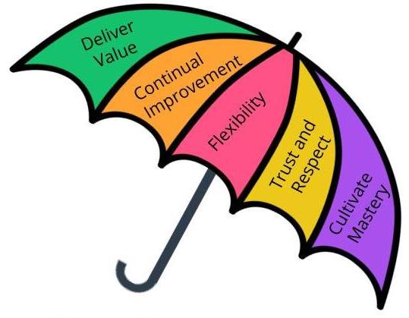

The Agile Umbrella

### **New Terms**

* **Agile Umbrella**: A term that refers to the various Agile Frameworks that follow the Agile Manifesto's values and principles

### **Additional Resources**

* [**Five Powerful Enterprise Agile Frameworks(opens in a new tab)**](https://dzone.com/articles/five-powerful-enterprise-agile-frameworks-1): In this blog, Prabhu Arumugham walks through five Enterprise Agile frameworks that act as process 'blueprints' providing a set of Agile practices, organizational structure, roles, and other recommendations.

# Quizzes: Agile Frameworks

## Thinking About Agile Frameworks

